Assignment 2: Real Estate Case
Student: Di Ha
Boston University
Quantitative and Qualitative Decision-Making
Professor: Dr Dickson
Date: July 28th, 2021

TABLE OF CONTENTS
Executive Summary 3
Mainbody 4~6
Appendix. 7~13

Executive Summery
Our real-estate company is considering investing in three types of businesses: apartment building, office building, and warehouse building. Because the economic condition is unknown, the probability of each state of nature occurs is estimated. To make achieve the best ROI, our company decides to value if it is worth hiring an analyst. By assigning the possibility of a survey to be positive or negative, we calculate the result of the final EMV of $308,000, building an office building, and decide that not hiring an analyst can maximum our ROI. The tool we used is payoff tables, sensitivity analysis, and decision tree diagrams. The sensitivity test showed that if the possibility value is exceeding 99.8%, we can hire an analyst to achieve better ROI, otherwise, we should stay where we are now, and not hire any analysts. The reason behind is that the cost of hiring an analyst is higher than the benefit it brings. If we hire an analyst, our ROI would be brought down in best possibility.
In conclusion, we should not hire any analyst and should build an office building to achieve the best ROI.

Main Body
Task2-1
As a real estate company, our company has established three possible projects: apartment building, office building, and warehouse. Under three different economic conditions: optimistic conditions, realistic conditions, pessimistic conditions. After importing the dataset, the payoff table of three alternatives under three states of nature is built.
Because the survey fee has to be paid no matter the result is positive or negative, for the “hire an analyst” payoff table, 7,000 should be deducted in advance. The table is shown in Appendix 1. Survey results can be positive and negative, the probabilities of each result under different states of nature are determined differently based on the decision maker’s estimation.
A scratch of decision tree without probabilities and EMVs is drawn based on the payoff table. The decision tree shows the process of choosing the best EMV for the company. A total of 27 states of nature and 9 probabilities are combined together to compose three payoff tables. After finishing the three payoff tables, the next tasks will build based on this task.
Task 2-2
Based on task 2-1, the EMVs of each alternative is calculated. First of all, we use the amount under each state of nature to multiply its probability and add the outcomes of the three states of nature, the result is the EMV. After calculation, total of 9 EMVs are calculated:196000,308000,205200,202700,311000,212100,21900,98000,-25200. The nodes are assigned based on the decision tree scratch from task 1.
Because the probabilities of survey results are different, the positive report probability is 0.54, and the negative report probability is 0.46. By choosing the largest alternative, the EMV of the payoff table is generated. We choose $167,940 as of the EMV of hiring analyst with a positive result, and $45,080 as the EMV of hiring analyst with a negative result. By choosing the larger of two, the EMV of hiring a business analyst is $167,940. Comparing the EMV between Hire-a-business-analyst($167,940) and do-not-hire-a business-analyst($308,000), we choose the larger between two and result in $308,000 as our final EMV, which is located at node 1 at the decision tree. The final EMV would be the best we can earn among all the alternatives. I believe, hire a business analyst is not cost-efficient and the cost would exceed the benefit it brings at the most time, so we decide not to hire any analysts.
Task 2-3
We receive the best outcome from the EMV estimate if we build the office building and don't hire the analyst. However, we'd like to know under what conditions we might be able to hire the analyst. We created a line of do not hire an analyst fixed at $308,000 and a variation line of the probability of a positive report result based on the sensitivity analysis (p). We suppose that probability is P and that the likelihood of a negative report outcome is 1-P. We can receive the amount of $98,000 at the point if P is equal to 0, and we can get the amount of $308,000 at the point if P is equal to 1.
A quadratic equation with one unknown line is drawn bypassing the line through two fixed points, namely $98,000 and $311,000. Another equation is a linear equation in one unknown, which is a constant number of $308,000. By calculating the cross point, the cross point P is 0.986. This means that when the chance of a positive report result is 0.986, the outcomes of both hire and non-hire are $308,000; when the probability is less than 0.986, the outcomes are less than $308,000; and when the probability is greater than 0.986, the outcomes are larger than $308,000. Therefore, when decision-maker decide
To simplify things, if p < 0.986, then the company should not hire the business analyst; if (p) equals 0.986, it doesn't matter if the company hires the analyst or not, as the profit will be equal to $308,000; if (p) is greater than 0.986, then the company should hire the business analyst since the company will make a profit of at least $308,000.
Task 2-4
The complicated version of the decision tree is shown under the appendix, the thought process of choosing the final EMV is exactly what the decision tree pictures.

Appendix 1
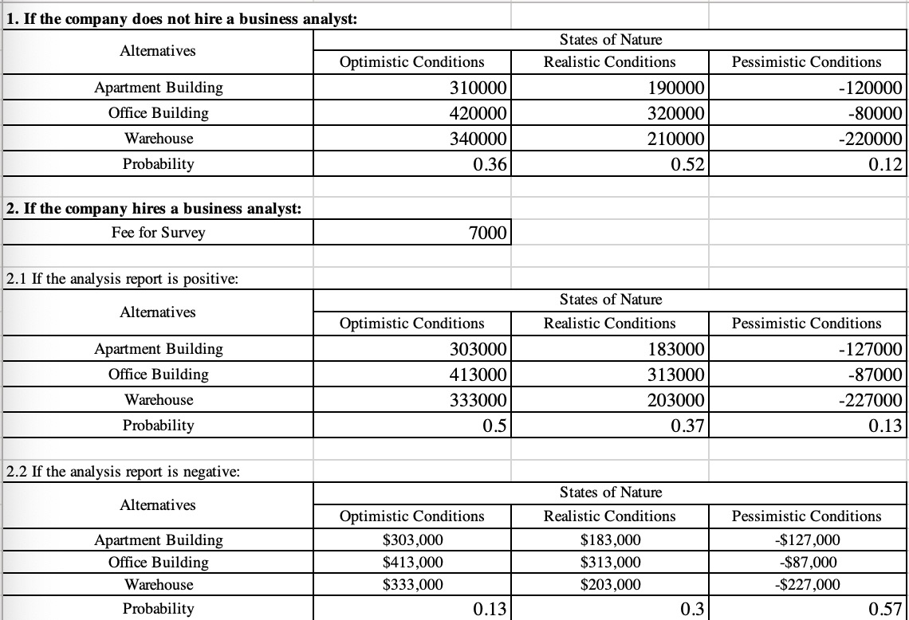
Appendix 2
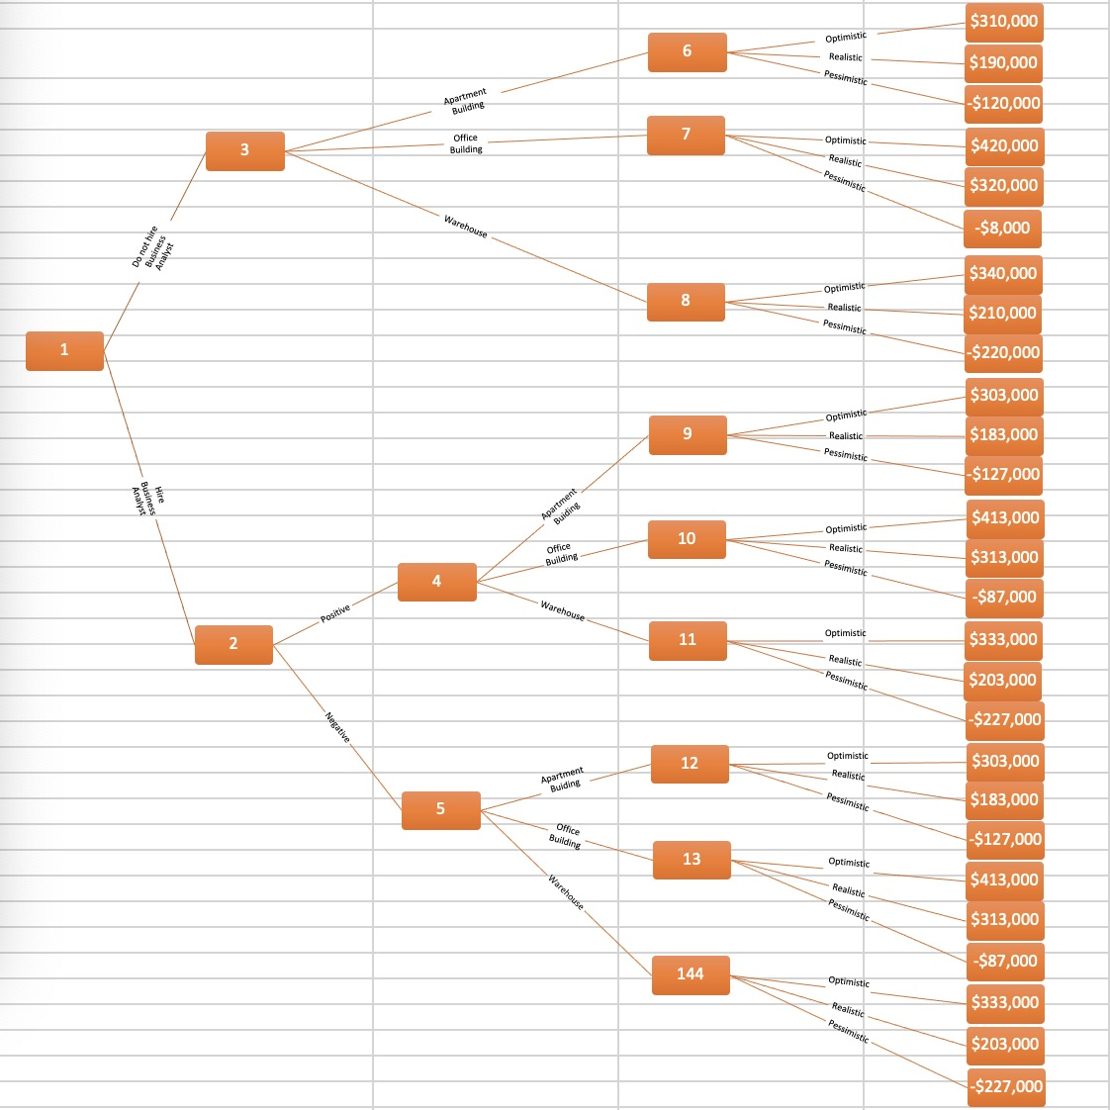

Appendix 3
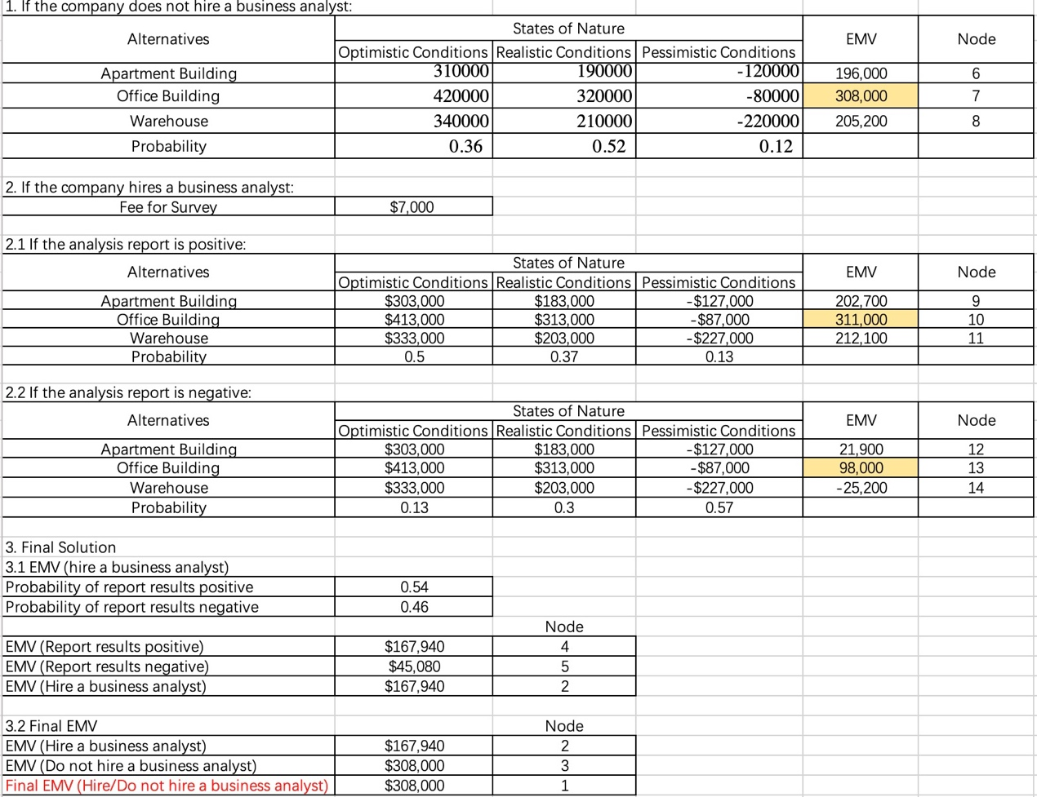
Appendix 4
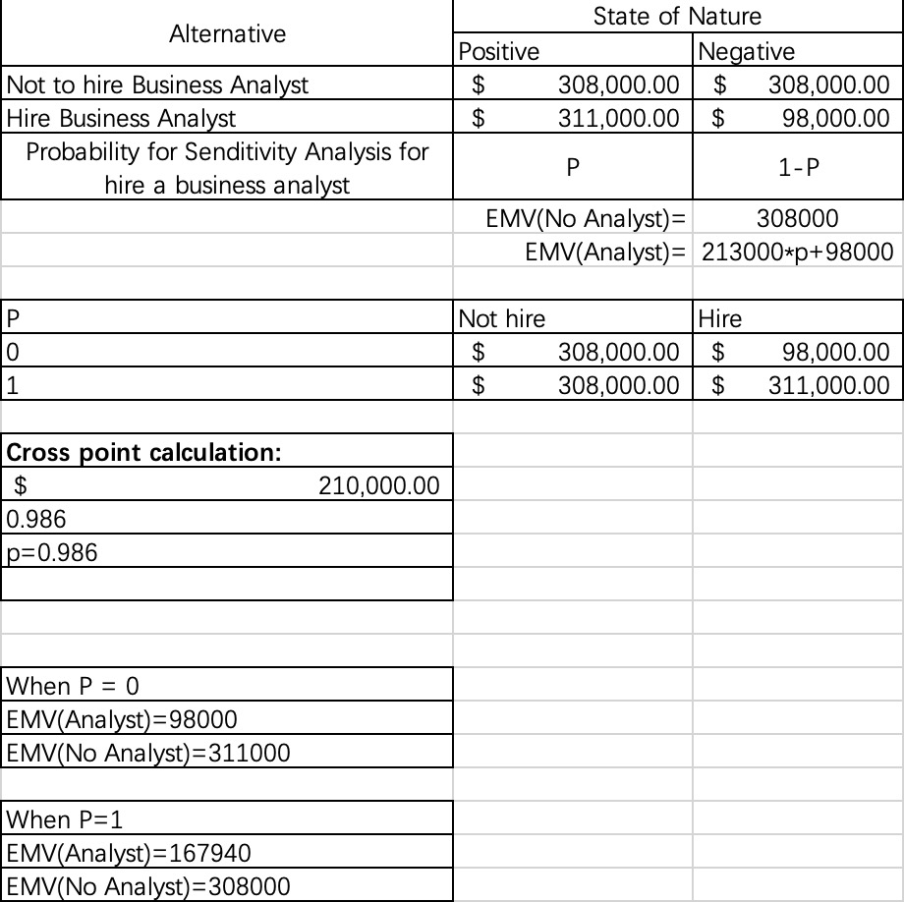
Appendix 5
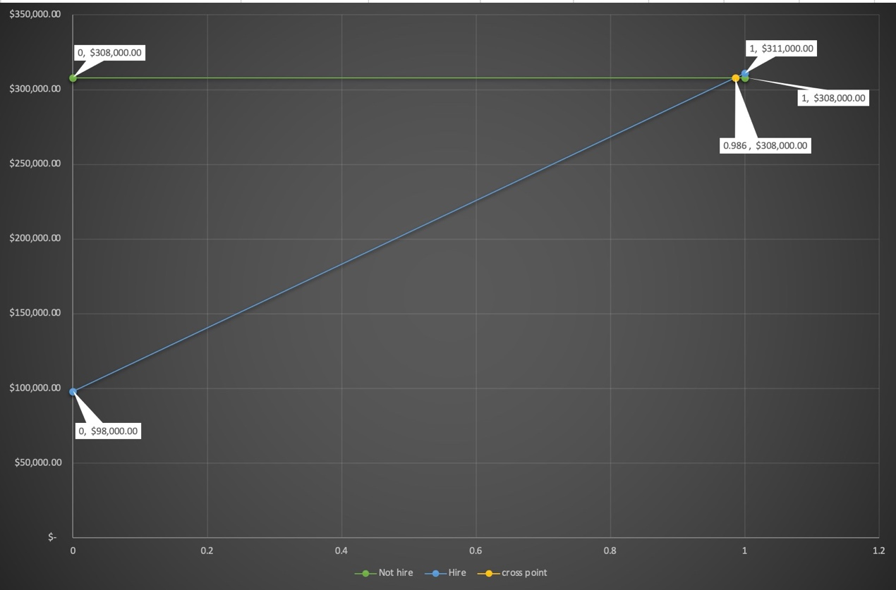

Appendix 6
